**Verifying the Database State**

VaporGames has just hired you as a new database developer. In order to become familiar with their current database design, you have been asked to perform some simple queries.

For this assignment, write queries that will answer the questions below. Save every query to a SQL script named VerifyDBState. Use -- to write a comment above each query, noting the question it refers to. Additionally, take a screenshot of the query and result set for each question, and insert it below the corresponding question.  
  
Example Screenshot: 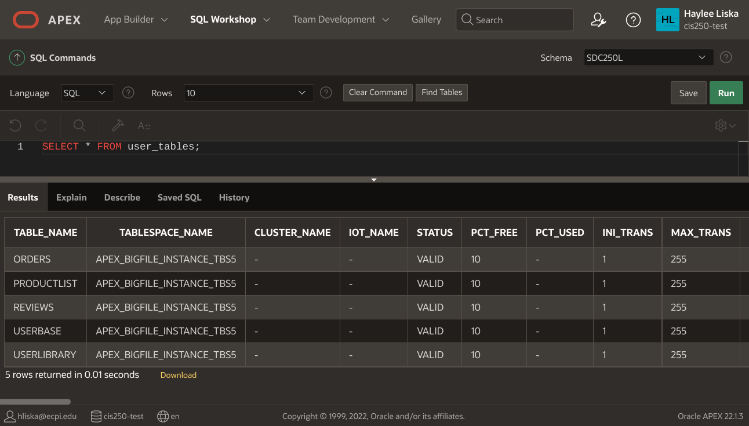

1. A screenshot of a computer

   AI-generated content may be incorrect.Check which users have access to the database by displaying the USER_ID, USERNAME, CREATED, and PASSWORD_CHANGE_DATE from the USER_USERS table.
2. Check what tables are present in the database by displaying everything in USER_TABLES.
3. Examine the design of each table by running the DESCRIBE command:
   * Describe the ORDERS table
   * Describe the PRODUCTLIST table
   * Describe the REVIEWS table
   * Describe the STOREFRONT table
   * Describe the USERBASE table
   * A screenshot of a computer

     AI-generated content may be incorrect.Describe the USERLIBRARY table

1. Display all data currently present in the database:  
   * Display everything in the ORDERS table
   * Display everything in the PRODUCTLIST table
   * Display everything in the REVIEWS table
   * Display everything in the STOREFRONT table
   * Display everything in the USERBASE table
   * Display everything in the USERLIBRARY table

1. Check what constraints are present in the database by displaying the TABLE_NAME, CONSTRAINT_NAME, CONSTRAINT_TYPE, and STATUS from the A screenshot of a computer

   AI-generated content may be incorrect.USER_CONSTRAINTS table.
2. Check what views are present in the database by displaying the VIEW_NAME and TEXT columns in the USER_VIEWS table.

**NOTE:** *no data found* is an acceptable answer! This means the query ran without error, but there were no records found (no data present in the table matching the selected conditions).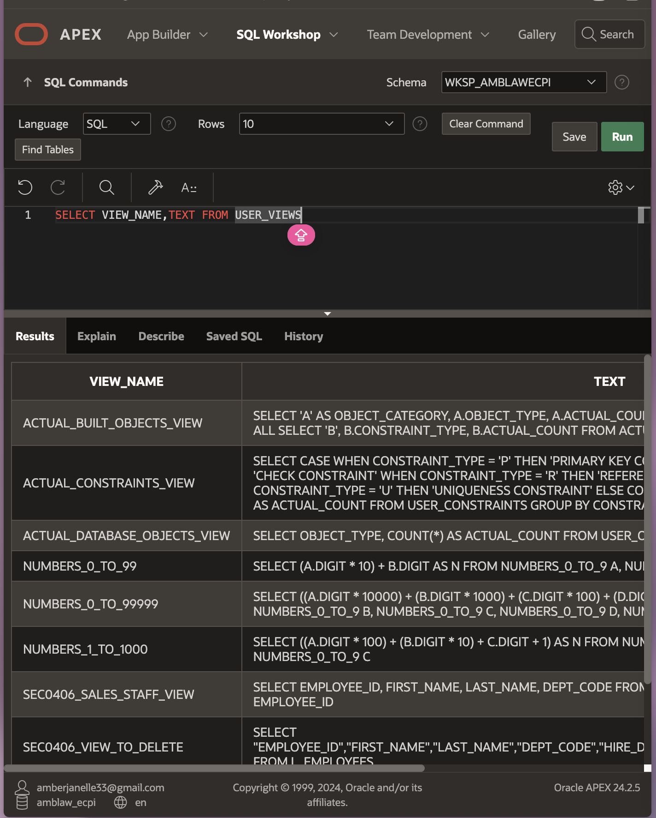

1. Display every USERNAME in alphabetical order.  
   A screenshot of a computer

   AI-generated content may be incorrect.
2. Display the FIRSTNAME, LASTNAME, USERNAME, PASSWORD, and EMAIL of any user who has a yahoo email address.  
   A screenshot of a computer

   AI-generated content may be incorrect.
3. Display the USERNAME, BIRTHDAY, and WALLETFUNDS of any user who has less than $25 in funds.  
   A screenshot of a computer

   AI-generated content may be incorrect.
4. Display the USERID and PRODUCTCODE of any user who has more than 100 HOURSPLAYED.  
   A screenshot of a computer

   AI-generated content may be incorrect.
5. Display the PRODUCTCODE of any game that has less than 10 HOURSPLAYED.  
   A screenshot of a computer

   AI-generated content may be incorrect.
6. Display every unique PUBLISHER.  
   A screenshot of a computer

   AI-generated content may be incorrect.
7. Display the PRODUCTNAME, RELEASEDATE, PUBLISHER, and GENRE of all products, sorted by GENRE.  
   A screenshot of a computer

   AI-generated content may be incorrect.
8. Display the PRODUCTCODE and PUBLISHER of any product in the ‘Strategy’ GENRE.  
   A screenshot of a computer

   AI-generated content may be incorrect.
9. Display the PRODUCTCODE, DESCRIPTION, and PRICE for any product that costs more than $25, sorted by descending PRICE.  
   A screenshot of a computer

   AI-generated content may be incorrect.
10. Display the INVENTORYID and PRICE of all products in the STOREFRONT table, sorted by ascending PRICE.  
    A screenshot of a computer

    AI-generated content may be incorrect.
11. Display the PRODUCTCODE and REVIEW of any product with a RATING of 1.  
    A screenshot of a computer

    AI-generated content may be incorrect.
12. Display the PRODUCTCODE and REVIEW of any product with a RATING of 4 or higher.  
    A screenshot of a computer

    AI-generated content may be incorrect.
13. Display every unique USERID from users who have placed an order.  
    A screenshot of a computer

    AI-generated content may be incorrect.
14. A screenshot of a computer

    AI-generated content may be incorrect.Display all order data, sorted by the earliest PURCHASEDATE.

Git: <https://github.com/LawSwan/SDC250L> - Lawson

<https://github.com/Godhonestliar/week1_SDC250L/blob/main/SDC250L/WEEK%201/1.4%20Verifying%20the%20Database%20State> – Torran